Setting up RDP in an Ubuntu AWS EC2 Instance

**Step 1: Connecting to the remote server**

We need to login to the remote server via ssh in order to install various packages and prepare the environment. For this EC2 provides the command to connect to your instance. Just click on the “Connect” button towards to top right corner of the EC2 Service Page.

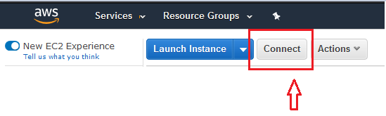

**Step 2: Create a new User:**

This step is important as even though AWS provides you with a user “ubuntu”, but EC2 doesn’t provide a password for this user which will be required while login. You may try to follow the below approach of changing the password of “ubuntu” user but I prefer to create a new user and do all of my development under that user.

# Change to the super user  
sudo su –

# Provide a password for the "ubuntu" user  
passwd Ubuntu

**Step 3: The actual Installation**

Once we are connected to our remote instance, we are now ready to setup the xRDP server

sudo apt-get update

sudo apt-get install xrdp

Installing a desktop environment : XFCE in our case as xRDP has problems working with Unity and GNOME desktop environment.

sudo apt-get install xfce4

sudo apt-get install xfce4-terminal

Make xRDP to use the environment we just create

sudo sed -i.bak '/fi/a #xrdp multiple users configuration \n xfce-session \n' /etc/xrdp/startwm.sh

Provide the Firewall permissions, allowing RDP (running at port 3389) to go through the local firewall.

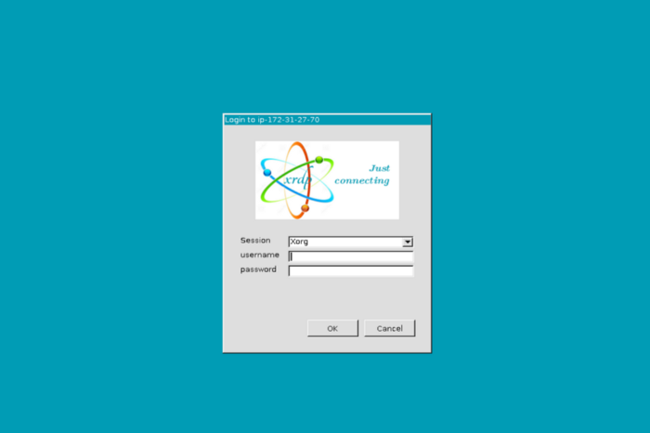

Step 4: Done

**setup of running ubuntu desktop on an AWS EC2 instance using TightVNC on a system running Ubuntu 16.04+.**

What you’ll need :

* Access to an AWS EC2 instance using commandline - This tutorial assumes that you’re logged into the machine using SSH
* A machine running ubuntu 16.04+
* Remmina Remote Desktop Client (Pre-installed on 16.04+)

## **2. Setting up TightVNC on AWS**

While installing VNC Server you’ll be required to setup a password for the server. So remember this since it will be needed later to connect to our VNC server.

sudo apt update

sudo apt install ubuntu-desktop

sudo apt install tightvncserver

sudo apt install gnome-panel gnome-settings-daemon metacity nautilus gnome-terminal

After completion, your machine is ready with GUI support but needs some configuration to be done.

## **3. Configuring the VNC server**

In your terminal type the following command to launch VNC server to create an initial configuration file:

vncserver :1

Open the configuration file in vim:

vim ~/.vnc/xstartup

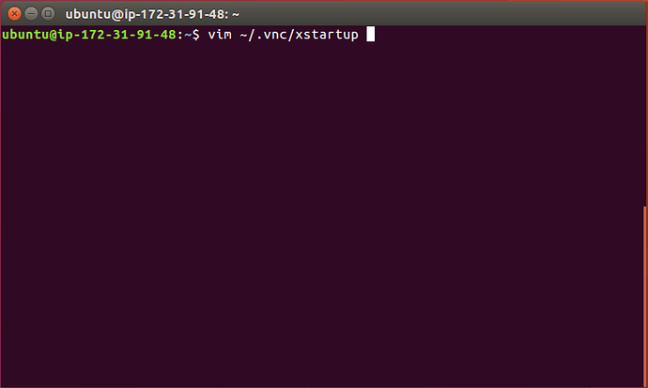

Press the ‘i’ key on your keyboard to get into the insert mode which will allow you to enter text into the file. Edit the file to look like so :

#!/bin/sh

export XKL_XMODMAP_DISABLE=1

unset SESSION_MANAGER

unset DBUS_SESSION_BUS_ADDRESS

[ -x /etc/vnc/xstartup ] && exec /etc/vnc/xstartup

[ -r $HOME/.Xresources ] && xrdb $HOME/.Xresources

xsetroot -solid grey

vncconfig -iconic &

gnome-panel &

gnome-settings-daemon &

metacity &

nautilus &

gnome-terminal &

After you’re done, enter ‘*Ctrl + :*’ and type ‘*wq*’ to save and quit the file.

[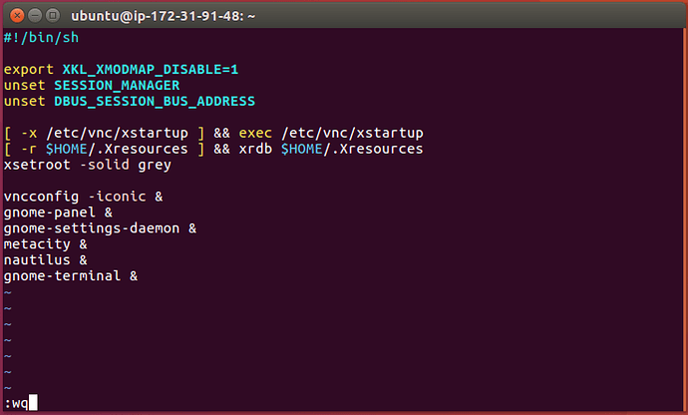](https://ubuntucommunity.s3.dualstack.us-east-2.amazonaws.com/original/2X/4/451b9ac602a161d95a4dbd728b5d7f126e2285d7.png)

Great! We’re almost done with the configuration. Now, let’s restart the VNC server by killing it first and then starting it up.

To kill the vnc server and start it again, type the following command:

vncserver -kill :1

vncserver :1

Congratulations, you’re done with the configuration for Ubuntu Desktop.

## **4. AWS Configuration**

We need to make sure that the AWS instance has inbound rules setup to allow connection using VNC. So, head over to your AWS EC2 console and modify the inbound-rules. Add the entry : Custom TCP Rule | TCP | 5901 | Custom | 0.0.0.0/0 | VNC Connect

[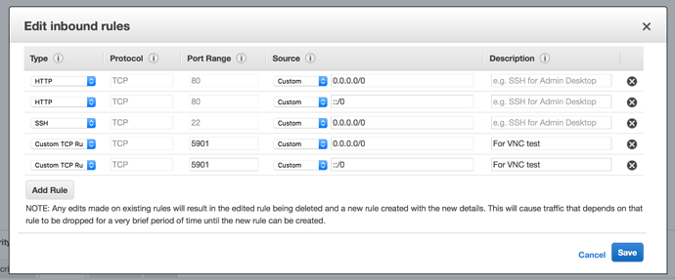](https://ubuntucommunity.s3.dualstack.us-east-2.amazonaws.com/original/2X/5/51637358503cf54d0d03b663fdc44d8e76b042c5.png)

Save this entry. Done!